SCHOOL OF TECHNOLOGY | 

DATABASE MANAGEMENT SYSTEMS
PROJECT-BASED LEARNING (PBL) REPORT
Small Database Application Development using Java / Python

PROJECT TITLE
DESIGN AND IMPLEMENTATION OF A DATABASE MANAGEMENT SYSTEM FOR EMPLOYEE ATTENDANCE, SHIFT AND LEAVE MANAGEMENT SYSTEM

Program | B.Tech CSE (AI & ML)
Section | AIML Rhinos
Faculty | Dr. Sahithi
Date of Submission | 6-10-2026
Academic Year | 2025– 29

Submitted by
Roll Number | Student Name | Mobile | Email ID
25WU0102106 | J. Vaishnav Sujith | 7995500183 | vaishnav.jannam_2029@woxsen.edu.in

ACKNOWLEDGEMENT

I express my sincere gratitude to Woxsen University, School of Technology, for providing me with the opportunity to undertake this Project-Based Learning (PBL) activity as part of the Database Management Systems (DBMS) course.
I thank my course faculty, Name of the Faculty, for the guidance, suggestions, and support throughout the design and development of this project. The guidance helped me understand the practical application of database concepts such as ER modelling, relational schema design, normalization, SQL, constraints, queries, and database application development.
This PBL activity has strengthened my understanding of DBMS concepts and provided valuable experience in applying them to a real-world problem.

UNDERTAKING

I hereby declare that the project entitled “[Project Title]”, submitted as part of the Project-Based Learning activity for the Database Management Systems (DBMS) course, is my individual work carried out under the guidance of the course faculty.
I undertake that the project report, database design, SQL scripts, application source code, results, and supporting materials submitted by me have been prepared for academic purposes. Wherever information, ideas, tools, datasets, or other resources have been referred to, appropriate acknowledgement has been provided.
I further undertake that I am responsible for the correctness and authenticity of the work submitted and that I have followed the academic and project guidelines prescribed by the University.

 |  |  |  | Signature
Date | : | 6-10-2026 | Name: J.Vaishnav
Place | : | Woxsen University | Rollno.:25WU0102106
 |  |  | Program:AIML

TABLE OF CONTENTS

Use this common structure for all DBMS PBL projects. Enter or update the page numbers after completing the report.
Contents | Page No.
Abstract
LIST OF TABLES
LIST OF FIGURES
LIST OF ACRONYMS
1. PROBLEM STATEMENT, SOLUTION STRATEGY AND ER DIAGRAM
1.1 Problem Statement
1.2 Objectives
1.3 Scope and Assumptions
1.4 Proposed Solution Strategy
1.5 Functional Requirements
1.6 Entity-Relationship Diagram (ERD)
1.7 Entity and Relationship Summary
2. LOGICAL DATABASE DESIGN
2.1 Relational Schema
2.2 Keys and Integrity Constraints
2.3 Functional Dependencies
2.4 Normalization up to Third Normal Form (3NF)
2.5 Data Dictionary
2.6 Implementation of Logical Design: DDL and Sample Data
3. APPLICATION DEVELOPMENT USING LOGICAL DATABASE DESIGN
3.1 Application Overview
3.2 Development Environment and Database Connectivity
3.3 Application Modules and Database Mapping
3.4 CRUD Operations
3.5 Business Rules, Validation and Error Handling
3.6 Reports and Database Operations
3.7 Application Screens
3.8 Testing and Results
4. CONCLUSION
4.1 Limitations and Future Enhancements
5. REFERENCES
6. APPENDICES

LIST OF TABLES

Update this list after finalising the report. Use Word References > Insert Caption for every table and References > Insert Table of Figures with the caption label “Table”.
Table No. | Table Title | Page No.
Table 1 | Scope and Assumptions
Table 2 | Proposed Solution Strategy
Table 3 | Functional Requirements
Table 4 | Entity and Relationship Summary
Table 5 | Relational Schema
Table 6 | Keys and Integrity Constraints
Table 7 | Normalization Status up to 3NF
Table 8 | Data Dictionary
Table 9 | Database Implementation Environment
Table 10 | Application Development Environment
Table 11 | Application Module-to-Database Mapping
Table 12 | CRUD Operations
Table 13 | Business Rules, Validation and Error Handling
Table 14 | Reports and Database Operations
Table 15 | Test Cases

LIST OF FIGURES

Update this list after finalising the report. Use Word References > Insert Caption for every figure and References > Insert Table of Figures with the caption label “Figure”.
Figure No. | Figure Title | Page No.
Figure 1 | Entity-Relationship Diagram of the Proposed System
Figure 2 | [Application Screen / Output Title]
Figure 3 | [Application Screen / Output Title]
Figure 4 | [Application Screen / Output Title]
Figure 5 | [Application Screen / Output Title]

LIST OF ACRONYMS

Retain only the acronyms used in the report and add any project-specific acronyms. All the Acronyms to be sorted order.
Acronym | Expansion

ABSTRACT
Employee attendance, shift allocation and leave processing require accurate coordination of employees, departments, rosters, time punches, overtime and leave balances. Spreadsheet-based or manual consolidation can cause duplicate records, delayed approvals and inconsistent payroll inputs. This project proposes a relational database application that centralizes these activities and applies integrity constraints to maintain consistent records. The system is designed using an Entity-Relationship model and converted into a relational schema normalized up to Third Normal Form (3NF). MySQL is used as the target DBMS, while Python with a Tkinter interface is proposed for application development. The major functions include employee and department maintenance, shift definition, daily roster preparation, clock-in and clock-out recording, work-hour and lateness summaries, overtime approval, leave application processing, leave-balance tracking and holiday maintenance. SQL joins, aggregate functions, nested queries and report queries support roster visibility, lateness monitoring, overtime totals, leave balances and department summaries. Primary and foreign keys, UNIQUE, NOT NULL, CHECK and DEFAULT constraints support data integrity, while indexes improve common date- and status-based searches. Transaction-aware approval workflows and input validation are included in the design. The project provides a practical demonstration of database modelling, normalization, SQL implementation and database-connected application development.
Keywords: Employee Attendance, Shift Scheduling, Leave Management, MySQL, Third Normal Form, Python GUI

CHAPTER 1

PROBLEM STATEMENT, SOLUTION STRATEGY AND ER DIAGRAM

1.1 Problem Statement

Organizations that operate with multiple shifts must coordinate employee schedules, attendance punches, lateness, overtime, leave applications, approvals and available leave balances. When these records are maintained separately in spreadsheets or paper registers, the same employee or date may be recorded more than once, roster changes may not reach all users, and managers may spend significant time preparing summaries. Incorrect or delayed records can also affect staffing decisions and payroll preparation.
The proposed Employee Attendance, Shift and Leave Management System uses a centralized relational database to store the related information and provide controlled operations for employees, managers and administrators. It aims to improve consistency, traceability and reporting. The database design is a project prototype; payroll calculation, biometric-device integration and production security deployment are outside the initial scope.

1.2 Objectives

Design an ER model covering employees, departments, shifts, rosters, attendance, overtime, leave and holidays.

Convert the ER model into relational tables with primary keys, foreign keys and suitable integrity constraints.

Normalize the relations up to Third Normal Form (3NF) and document important functional dependencies.

Develop a Python-based interface concept for roster management, attendance entry, leave/overtime decisions and reports.

Validate key business rules and prepare SQL queries and test cases for common positive and negative scenarios.

1.3 Scope and Assumptions
Table 1. Scope and Assumptions
Item | Description
In Scope | Employee and department records; shift definitions; daily roster assignments; IN/OUT punches; daily attendance summaries; overtime requests and decisions; leave types, balances and applications; holidays; SQL reports.
Out of Scope / Exclusions | Payroll disbursement, biometric hardware, GPS tracking, mobile push notifications, statutory compliance automation and integration with external HR systems.
Assumptions | Each employee belongs to one department; a roster assigns at most one shift to an employee per date; overnight shifts are allowed; an authorized manager/admin makes approval decisions; sample records are fictional; approved leave updates the relevant leave balance within a transaction

1.4 Proposed Solution Strategy
Table 2. Proposed Solution Strategy
Solution Element | Project-Specific Description
Primary Users / Roles | Administrator maintains departments, employees, shifts, holidays and access roles. Manager prepares rosters and approves/rejects overtime and leave. Employee records attendance and submits requests.
Major Application Modules | Dashboard; employee/department maintenance; shift and roster management; attendance punch entry and daily summary; overtime requests; leave types, applications and balances; holidays; reports
Proposed Workflow | Create departments and employees; define shifts; assign a roster; capture clock-in/out punches; calculate daily worked and late minutes; accept leave/overtime requests; validate and approve/reject requests; generate reports.
Important Business Rules | Clock-out must be later than clock-in; no overlapping assigned shifts; one daily summary per employee; leave approval must not exceed available balance; overtime requires an authorized decision; rejected/pending requests do not change balances.
Expected Reports / Outputs | Daily roster; late arrivals; absences; employee attendance summary; approved overtime totals; leave balance by employee/type; leave request status; department headcount and shift coverage.

1.5 Functional Requirements
Table 3. Functional Requirements
Req. ID | Functional Requirement | Remarks / Priority
FR-01 | Create, search and update employee and department details | High
FR-02 | Define shifts and assign one shift per employee per work date. | High
FR-03 | Record attendance punches and calculate work and lateness summaries. | High
FR-04 | Submit and process overtime requests with an approver and decision status. | High
FR-05 | Submit leave applications, validate available balance and update balance after approval. | High

1.6 Entity-Relationship Diagram (ERD)
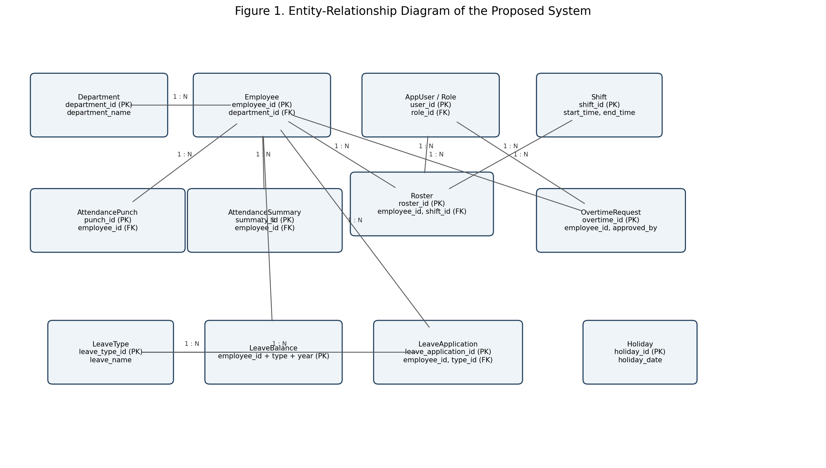Figure 1. Entity-Relationship Diagram of the Proposed System

1.7 Entity and Relationship Summary
Table 4. Entity and Relationship Summary
Entity / Relationship | Major Attributes / Cardinality | Purpose / Rule
Department | department_id, department_name, location | One department has many employees
Employee | employee_id, department_id, name, email, hire_date, status | Belongs to one department; parent record for attendance and requests.
Shift | shift_id, shift_name, start_time, end_time, break_minutes | Can be assigned to many roster rows.
Attendance Punch | punch_id, employee_id, punch_type, punch_time | Stores raw IN/OUT events for an employee.
AttendanceSummary | summary_id, employee_id, work_date, first_in, last_out, worked_minutes, late_minutes, status | At most one daily summary per employee.

CHAPTER 2

LOGICAL DATABASE DESIGN

This chapter should document how the approved ER model was converted into a correct relational database design and verified through a database prototype.

2.1 Relational Schema
List every relation derived from the ER model. Identify primary and foreign keys clearly.
Table 5. Relational Schema

2.1 Relational Schema
S.No. | Relation | Purpose
1 | Department | Department(department_id PK, department_name UNIQUE, location)
2 | Employee | Employee(employee_id PK, department_id FK, first_name, last_name, email UNIQUE, phone UNIQUE, hire_date, employment_status)
3 | UserRole | UserRole(role_id PK, role_name UNIQUE)
4 | AppUser | AppUser(user_id PK, employee_id FK UNIQUE, role_id FK, username UNIQUE, password_hash, is_enabled)
5 | Shift | Shift(shift_id PK, shift_name UNIQUE, start_time, end_time, break_minutes)
6 | Roster | Roster(roster_id PK, employee_id FK, shift_id FK, shift_date, assigned_by FK, status, UNIQUE(employee_id, shift_date))
7 | AttendancePunch | AttendancePunch(punch_id PK, employee_id FK, punch_type, punch_time, source)
8 | AttendanceSummary | AttendanceSummary(summary_id PK, employee_id FK, work_date, first_in, last_out, worked_minutes, late_minutes, attendance_status, UNIQUE(employee_id, work_date))
9 | OvertimeRequest | OvertimeRequest(overtime_id PK, employee_id FK, work_date, requested_minutes, reason, status, approved_by FK, requested_at, decision_at)
10 | LeaveType | LeaveType(leave_type_id PK, leave_name UNIQUE, annual_quota)
11 | LeaveBalance | LeaveBalance(employee_id PK/FK, leave_type_id PK/FK, leave_year PK, entitled_days, used_days)
12 | LeaveApplication | LeaveApplication(leave_application_id PK, employee_id FK, leave_type_id FK, start_date, end_date, days_requested, reason, status, approved_by FK, applied_at, decision_at)
13 | Holiday | Holiday(holiday_id PK, holiday_date UNIQUE, holiday_name, applies_to)

2.2 Keys and Integrity Constraints
Table 6. Keys and Integrity Constraints
Include PRIMARY KEY, FOREIGN KEY, UNIQUE, NOT NULL, CHECK, DEFAULT and suitable referential actions where applicable.
Constraint | Attributes / Example | Business Rule
Primary keys | Every entity has a primary key; LeaveBalance uses the composite key (employee_id, leave_type_id, leave_year). | Prevents duplicate identity.
Foreign keys | Employee.department_id; Roster.employee_id/shift_id/assigned_by; attendance employee references; request approver references; leave type and balance references. | Prevents orphan records.
UNIQUE | Department.department_name; Employee.email and phone; AppUser.username and employee_id; Shift.shift_name; Roster(employee_id, shift_date); AttendanceSummary(employee_id, work_date); Holiday.holiday_date. | Prevents duplicate business identifiers and daily rows.
NOT NULL | Required names, dates, types, statuses and foreign keys are mandatory. | Prevents incomplete required records.
CHECK | Allowed statuses and punch types; positive request minutes/days; non-negative work/late minutes; used leave not greater than entitlement; valid date range. | Rejects invalid values where supported by the DBMS.
DEFAULT | Active employee, enabled user, zero break/usage/minutes, pending requests and current timestamps. | Provides consistent initial values.

2.3 Functional Dependencies
- department_id → department_name, location
- employee_id → department_id, first_name, last_name, email, phone, hire_date, employment_status
- shift_id → shift_name, start_time, end_time, break_minutes
- roster_id → employee_id, shift_id, shift_date, assigned_by, status; (employee_id, shift_date) → roster_id, shift_id, assigned_by, status
- summary_id → employee_id, work_date, first_in, last_out, worked_minutes, late_minutes, attendance_status; (employee_id, work_date) → daily summary attributes
- leave_type_id → leave_name, annual_quota
- (employee_id, leave_type_id, leave_year) → entitled_days, used_days
- These dependencies are based on the intended keys and business rules. They are used to separate independent concepts into their own relations and avoid repeated descriptive data.

2.4 Normalization
Table 7. Normalization Status up to 3NF
Normal Form | Requirement / Analysis | Status
1NF | All attributes store single/atomic values; multiple punches and multiple leave requests are represented as separate rows, not repeating columns. | Satisfied by the proposed schema.
2NF | Relations are in 1NF and non-key attributes depend on the whole key. LeaveBalance values depend on the full composite key (employee, leave type, year). | No partial dependency is intended.
3NF | Non-key attributes depend on keys, not on other non-key attributes. Department names remain in Department; shift details remain in Shift; leave names remain in LeaveType; role names remain in UserRole. | Reduces update, insertion and deletion anomalies.

2.5 Data Dictionary
Prepare the data dictionary for all tables. Add rows as required.
Table 8. Data Dictionary
Table | Attributes / Types / Constraints | Description
Department | department_id INT PK; department_name VARCHAR(80) UNIQUE NOT NULL; location VARCHAR(100) | Department master.
Employee | employee_id INT PK; department_id INT FK; first_name/last_name VARCHAR(60); email VARCHAR(120) UNIQUE; hire_date DATE; employment_status VARCHAR(15) | Employee profile and department.
Shift | shift_id INT PK; shift_name VARCHAR(50) UNIQUE; start_time/end_time TIME; break_minutes INT | Shift definition; overnight shift allowed.
Roster | roster_id INT PK; employee_id INT FK; shift_id INT FK; shift_date DATE; assigned_by INT FK; status VARCHAR(15) | Daily shift assignment.
AttendancePunch | punch_id BIGINT PK; employee_id INT FK; punch_type VARCHAR(10); punch_time DATETIME; source VARCHAR(20) | Raw attendance event.
AttendanceSummary | summary_id BIGINT PK; employee_id INT FK; work_date DATE; first_in/last_out DATETIME; worked_minutes/late_minutes INT; attendance_status VARCHAR(15) | Calculated daily attendance.
OvertimeRequest | overtime_id BIGINT PK; employee_id INT FK; work_date DATE; requested_minutes INT; reason VARCHAR(255); status VARCHAR(15); approved_by INT FK | Overtime workflow.
LeaveType | leave_type_id INT PK; leave_name VARCHAR(50) UNIQUE; annual_quota DECIMAL(5,2) | Leave category and standard quota.
LeaveBalance | employee_id INT PK/FK; leave_type_id INT PK/FK; leave_year YEAR; entitled_days/used_days DECIMAL(5,2) | Annual leave balance.
LeaveApplication | leave_application_id BIGINT PK; employee_id/leave_type_id/approved_by FK; start_date/end_date DATE; days_requested DECIMAL(5,2); status VARCHAR(15) | Leave request and decision.
AppUser/UserRole | user_id/role_id INT PK; username and role_name UNIQUE; password_hash VARCHAR(255) | Identity and role metadata; store password hashes only.
Holiday | holiday_id INT PK; holiday_date DATE UNIQUE; holiday_name VARCHAR(100); applies_to VARCHAR(20) | Holiday calendar.

2.6 Implementation of Logical Design: DDL and Sample Data
Mention the DBMS used, provide representative CREATE TABLE statements with constraints, and show representative sample records. Attach the complete SQL script in Appendix A.
Table 9. Database Implementation Environment
Item | Details
DBMS | MySQL 8.0 or later
Number of tables | 13
Sample data | Fictional records for departments, employees, shifts, roster, punches, summaries, overtime, leave and holidays
Complete script | Appendix A / Employee_Attendance_Shift_Leave_DBMS.sql

[Insert representative DDL snippets and sample data / screenshots here.]

CHAPTER 3

APPLICATION DEVELOPMENT USING LOGICAL DATABASE DESIGN

This chapter should show how the approved logical database design is used by the final Java/Python application. The application must interact with the database rather than use isolated/static data.

3.1 Application Overview
The proposed front end is a small Python application using Tkinter for forms and a MySQL connector for database access. The interface is divided into employee/department maintenance, shifts and rosters, attendance, overtime, leave and reports. Each screen reads from or writes to the relational tables instead of relying on isolated static data. Parameterized SQL is used for user input. The design separates raw attendance punches from daily summaries so source events can be retained and summaries recalculated.

3.2 Development Environment and Database Connectivity
Table 10. Application Development Environment
Item | Details
Programming language | Python 3.x
DBMS | MySQL 8.0 or later
GUI toolkit | Tkinter
Connector | mysql-connector-python
Operating environment | Windows / Linux desktop; database server configured separately
Repository link | [Insert public GitHub repository URL after creating the repository]

3.3 Application Modules and Database Mapping
Table 11. Application Module-to-Database Mapping
Module / Screen | Purpose | Tables Used | Main Operations
Employee and department | Maintain master data | Employee, Department | INSERT, SELECT, UPDATE
Shift and roster | Define shifts and assign staff | Shift, Roster, AppUser | INSERT, SELECT, UPDATE; overlap validation
Attendance | Capture punches and display daily status | AttendancePunch, AttendanceSummary, Roster, Shift | INSERT punches; SELECT/UPDATE summary
Overtime | Submit and decide overtime | OvertimeRequest, Employee, AppUser | INSERT; UPDATE status and approver
Leave | Apply for leave and show balances | LeaveApplication, LeaveBalance, LeaveType, Holiday | INSERT; transactional approval/update
Reports | Filter and summarize operations | Most tables | JOIN, GROUP BY, aggregate and nested queries

3.4 CRUD Operations
Table 12. CRUD Operations
Operation | Application Feature / Screen | SQL Concept | Evidence to Capture
Create | Employee, roster, punch, overtime request and leave application forms | INSERT | Capture a new record with required-field validation.
Read / Search | Employee search, daily roster, attendance and balance reports | SELECT, JOIN, WHERE | Filter by employee, department, date or status.
Update | Employee details, roster status, approval decision and summary | UPDATE | Use parameterized queries and preserve audit fields.
Delete / controlled removal | Only eligible draft/master records with no dependent records | DELETE with FK restrictions or soft status | Require confirmation; do not delete approved attendance or requests casually.

3.5 Business Rules, Validation and Error Handling.
Table 13. Business Rules, Validation and Error Handling
Rule / Validation | How Implemented | Evidence / Message
No overlapping shifts | Before publishing a roster, compare the proposed interval with other published shifts for the same employee, including overnight intervals. | Reject conflicts and show the conflicting date/shift.
Clock-out after clock-in | Pair punch events and validate OUT timestamp is later than the corresponding IN; handle overnight shifts using date-aware logic. | Do not finalize a negative or incomplete duration.
Leave within balance | Within one transaction, lock/check the employee/type/year balance; approve only if available days cover the request; update used_days and application status together. | Rollback on any failure.
Authorized overtime | Check the current user's role before approval; record approver and decision timestamp. | Reject unauthorized action.
One daily summary | UNIQUE(employee_id, work_date) plus insert-or-update logic. | Avoid duplicate daily summaries.
Input and database errors | Use parameterized SQL, type/date validation, exception handling, rollback and safe user messages; never display passwords or raw credentials. | Keep a diagnostic log without secrets.

3.6 Reports and Database Operations
Table 14. Reports and Database Operations
Report / Operation | SQL / Database Concept | Application Output
Daily roster | JOIN Roster, Employee, Department and Shift; filter by shift_date and published status. | Employee list grouped by department/shift.
Late arrivals | JOIN AttendanceSummary and Employee; filter late_minutes > 0; order by date and lateness. | Late-arrival register.
Department headcount | LEFT JOIN Department to Employee; GROUP BY department. | Count of employees per department, including empty departments.
Leave balance | JOIN LeaveBalance, Employee and LeaveType; calculate entitled_days - used_days. | Available balance by employee and leave type.
Approved overtime | SUM(requested_minutes), grouped by employee and filtered to APPROVED. | Approved overtime totals.
Shift coverage | Count roster assignments by date and shift; compare against staffing target if configured. | Coverage count; target thresholds are future configuration.
Absence report | Compare published roster against daily attendance/approved leave for each date. | Rostered employees without punches, excluding approved leave and holidays.

3.7 Application Screens
Insert the important application screenshots. Place each figure caption below the screenshot using the format “Figure X. Figure Title”. Include screens that demonstrate data entry, search/display, update, a project-specific transaction and at least one report/output.
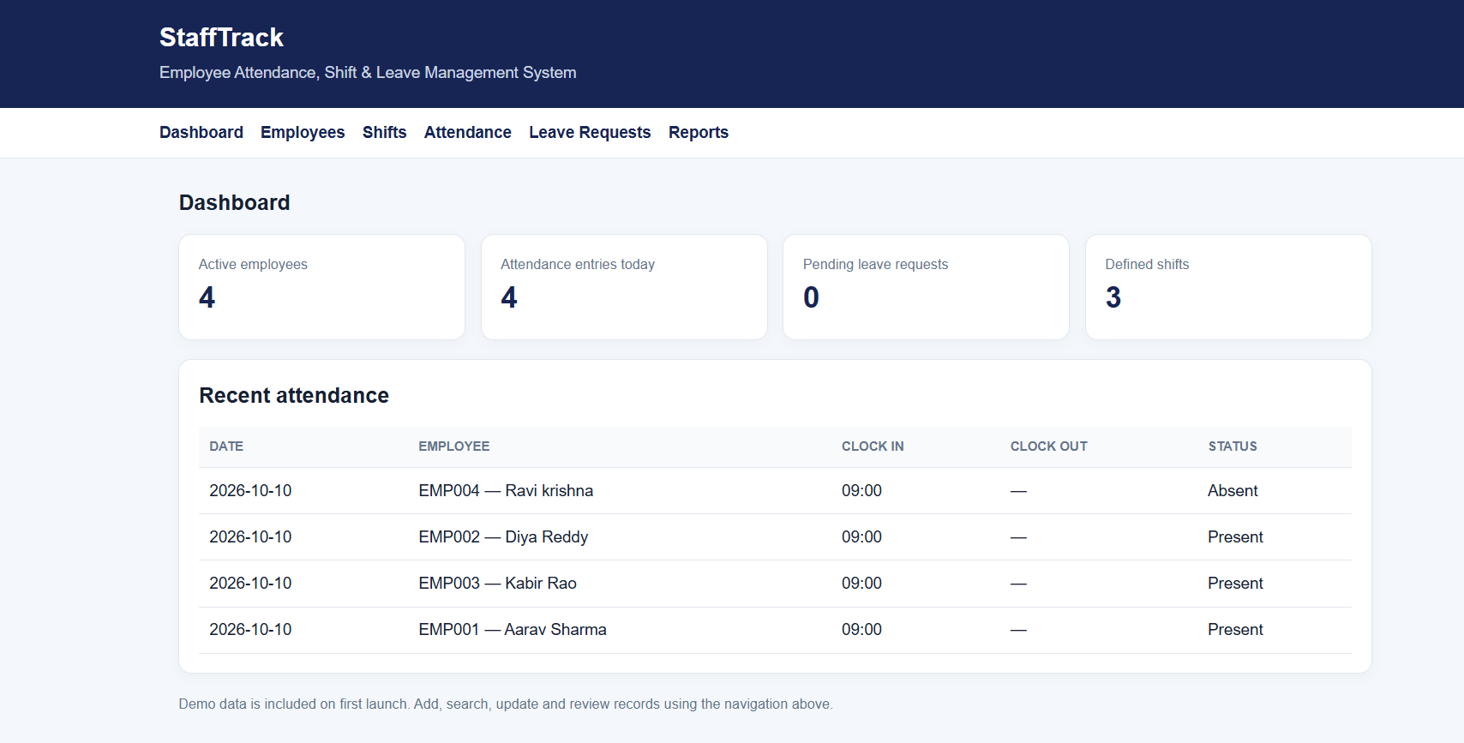
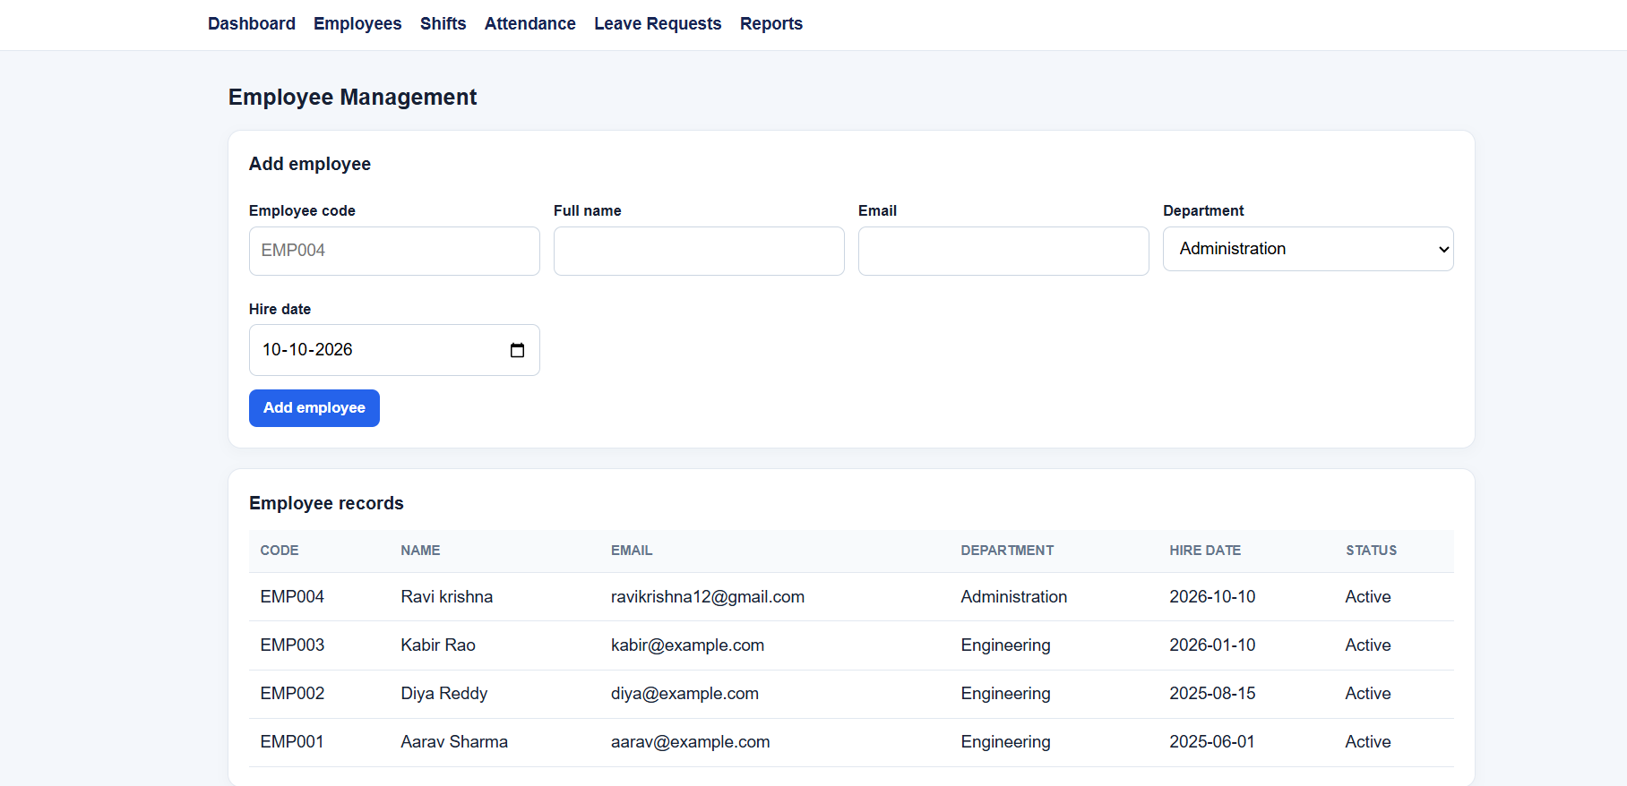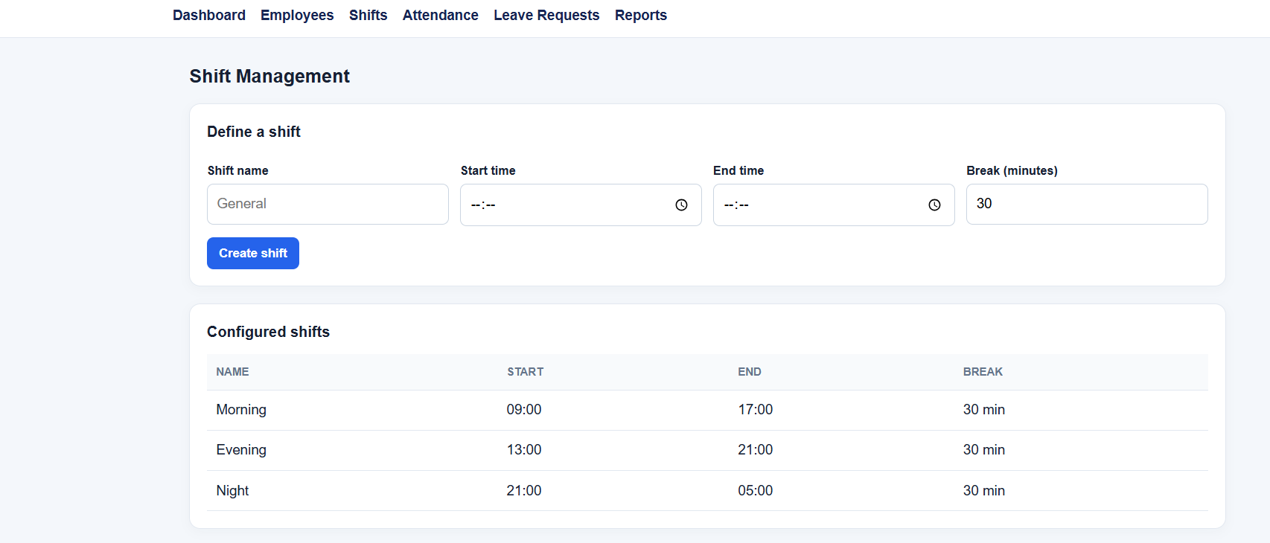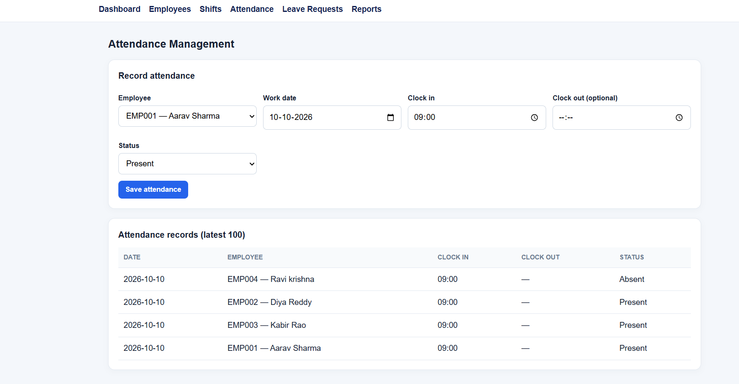

3.8 Testing and Results
Table 15. Test Cases
Test ID | Feature | Input / Action | Expected Result | Actual Result / Status
TC-01 | Create employee with valid department and unique email | Valid details | Employee row is saved and can be searched. | To be executed
TC-02 | Create employee with duplicate email | Existing email reused | UNIQUE constraint rejects duplicate. | To be executed
TC-03 | Assign two shifts to same employee/date | Second roster on same date | UNIQUE constraint rejects duplicate daily assignment; overlap check rejects time conflicts. | To be executed
TC-04 | Record clock-out before clock-in | OUT timestamp earlier than IN | Validation prevents summary finalization. | To be executed
TC-05 | Approve leave beyond available balance | Requested days > balance | Approval is rejected and balance remains unchanged. | To be executed
TC-06 | Approve overtime as employee role | Non-manager user attempts approval | Authorization check denies action. | To be executed
TC-07 | Generate late-arrival report | Date range with late summary | Only records with late_minutes > 0 are displayed. | To be executed
TC-08 | Force an error during leave approval transaction | Simulated database failure | Transaction rolls back both balance and status updates. | To be executed

The table lists planned verification cases. Run each case against the final application and replace “To be executed” with the observed outcome. Do not claim successful testing until the result has been observed and recorded.

CHAPTER 4
CONCLUSION

The project defines a relational database solution for employee attendance, shift scheduling, overtime and leave management. The design separates master data, roster assignments, raw attendance events, daily summaries and request workflows into related relations. Primary/foreign keys, uniqueness rules, CHECK/DEFAULT constraints and indexes support data integrity and common searches. Normalization up to 3NF reduces duplicated data and update anomalies. The proposed Python/Tkinter front end maps user operations to SQL CRUD actions and reports, while transaction-aware approval is required for leave-balance updates. The report and Appendix A provide a foundation for implementation and systematic verification. Since application execution evidence has not been supplied, the test cases are marked “To be executed” and must be updated with actual results before final submission.

4.1 Limitations and Future Enhancements
- Current report provides a database/application design and starter SQL script; actual GUI screenshots and observed test outcomes must be added after implementation.
- Biometric or mobile punch capture, email notifications and payroll integration can be added through authenticated APIs.
- Future versions can include configurable shift-overlap policies, department-specific holidays, audit history, dashboards and role-based access enforcement at both application and database layers.
- Production deployment should add secure password hashing, session management, least-privilege database accounts, backups, retention policies and privacy review.

REFERENCES

[1] R. Elmasri and S. B. Navathe, Fundamentals of Database Systems, 7th ed. Pearson, 2016.
[2] A. Silberschatz, H. F. Korth, and S. Sudarshan, Database System Concepts, 7th ed. McGraw-Hill, 2019.
[3] Oracle, “MySQL 8.0 Reference Manual,” accessed Oct. 12, 2026. [Online]. Available: https://dev.mysql.com/doc/refman/8.0/en/
[4] Python Software Foundation, “tkinter — Python interface to Tcl/Tk,” accessed Oct. 12, 2026. [Online]. Available: https://docs.python.org/3/library/tkinter.html
[5] Python Software Foundation, “PEP 249 — Python Database API Specification v2.0,” accessed Oct. 12, 2026. [Online]. Available: https://peps.python.org/pep-0249/

APPENDICES

APPENDIX A - COMPLETE DATABASE SCRIPT
The complete MySQL DDL, sample data, indexes and representative reporting queries are supplied as the companion file Employee_Attendance_Shift_Leave_DBMS.sql. Execute it in a test database after reviewing the sample data and MySQL version compatibility.

APPENDIX B - APPLICATION SOURCE CODE
Source-code folder/repository: [Insert the public GitHub repository URL after uploading the Python application and README. Do not claim a repository exists until it has been created and checked.]

APPENDIX C - ADDITIONAL TEST DATA AND OUTPUTS
Attach actual screenshots, query outputs and a completed test log here. Include evidence of successful data entry, search/display, update or transaction processing, and at least one report. Redact credentials and any real employee personal data.z

